

CSE 1002 PRograms



Name: pranay agrawal

Registration no: 22mis0172

**Experiment 3A:**

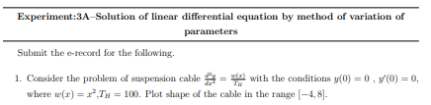

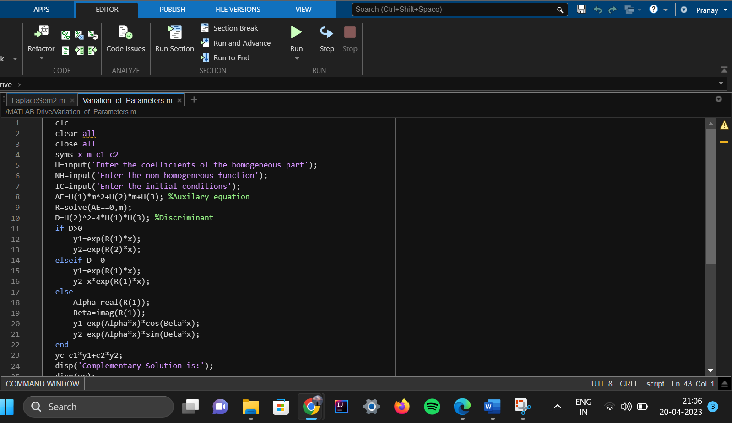**Code:**

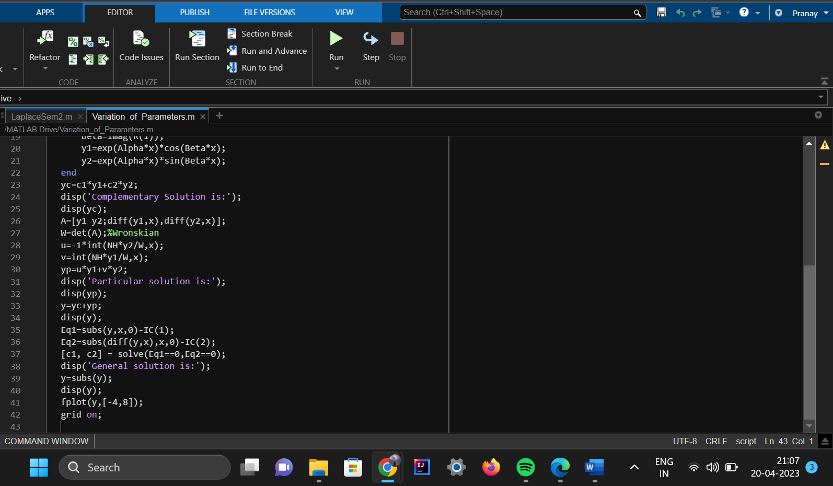

**Output:**

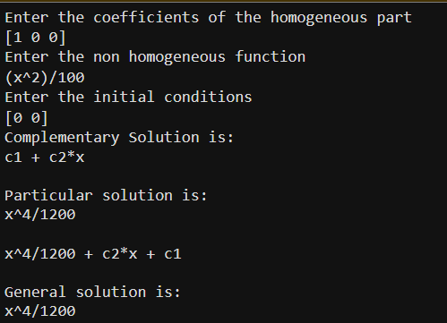

**Function Plot:**

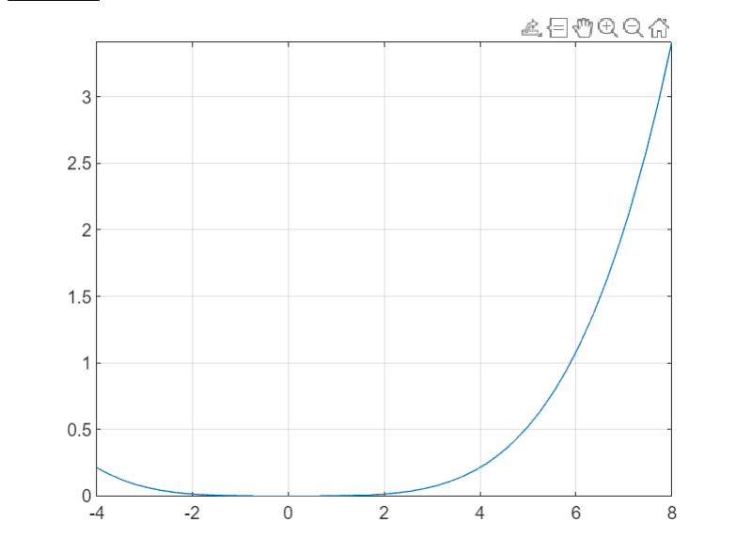

**Experiment 3B:**

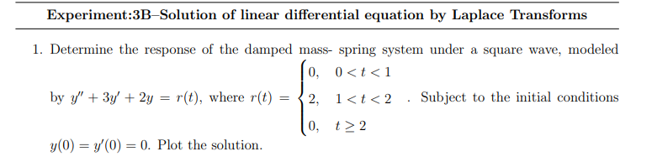

**Code:**

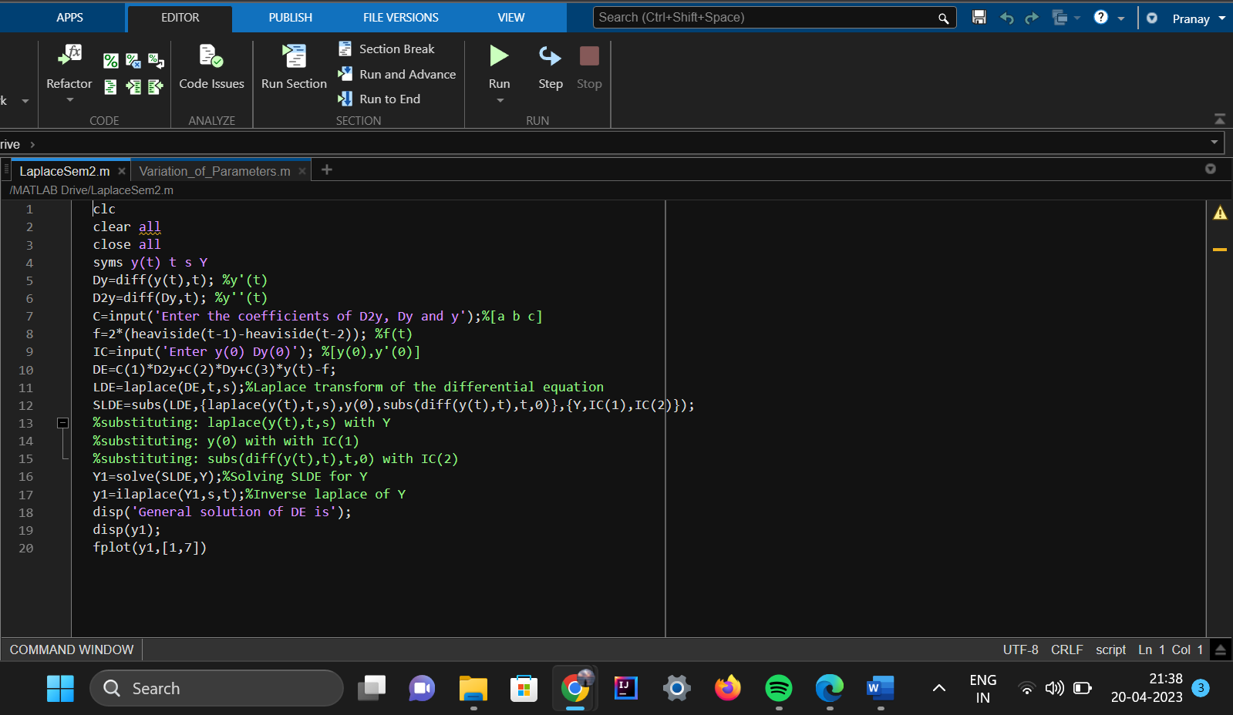

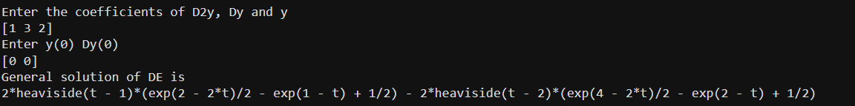**Output:**

**Function Plot:**

